CREATE JAVA APPLICATION

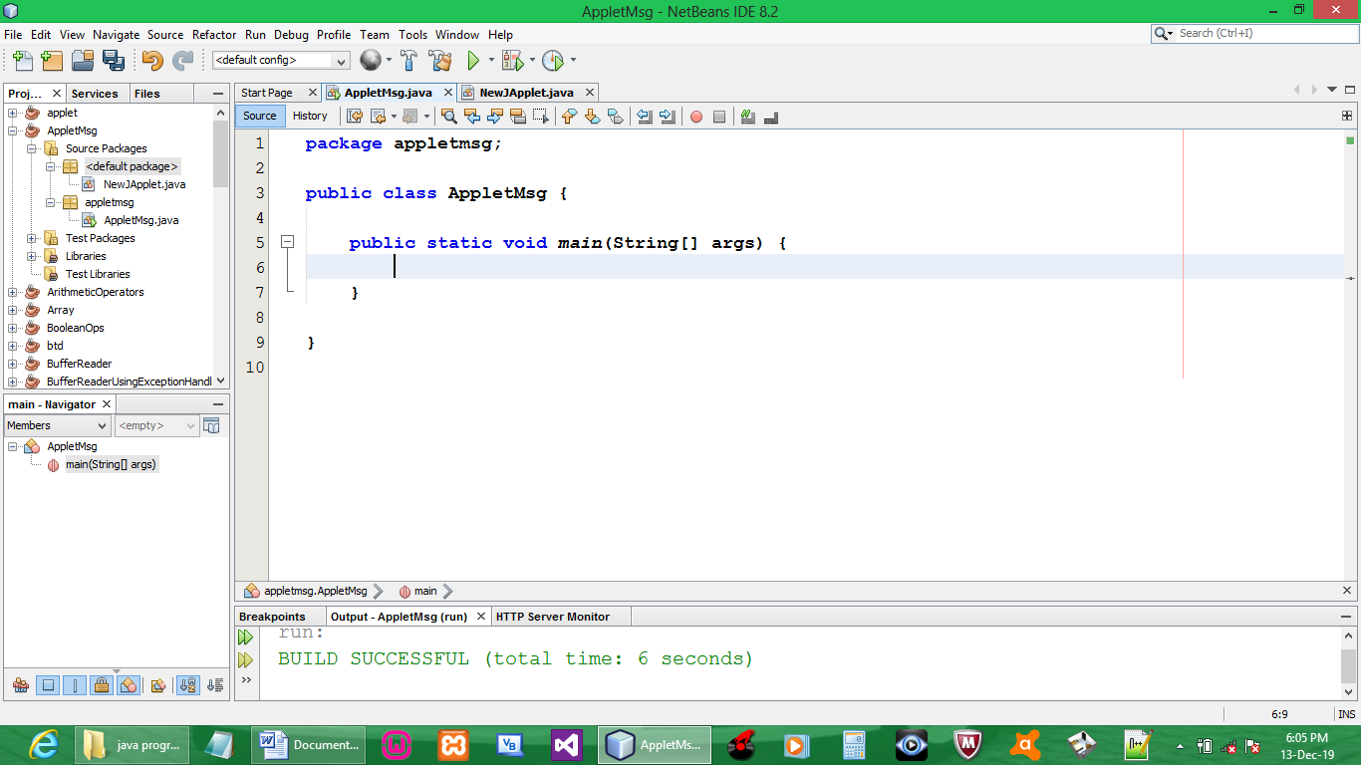

CREATE JAVA APPLET

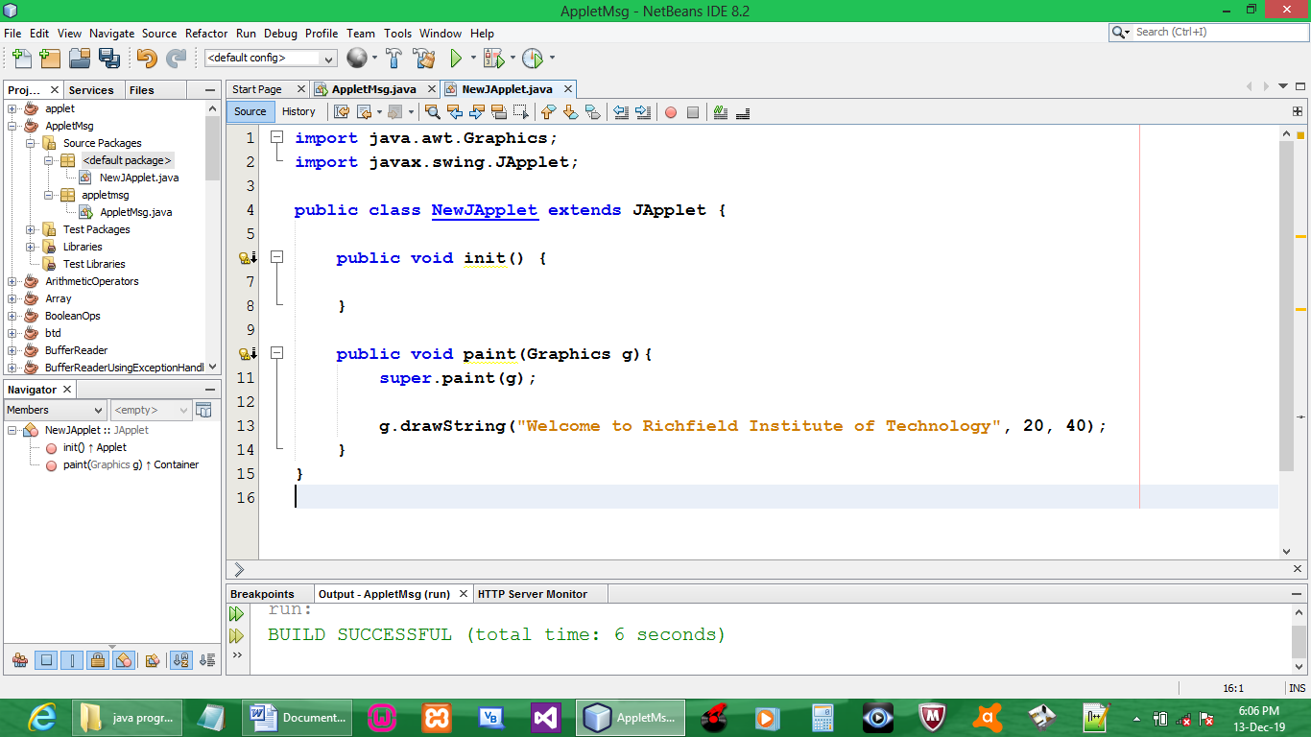

CODE:

import java.awt.Graphics;
import javax.swing.JApplet;

public class NewJApplet extends JApplet {

public void init() {

}

public void paint(Graphics g){
super.paint(g);

g.drawString("Welcome to Richfield Institute of Technology", 20, 40);
}
}

OUTPUT:

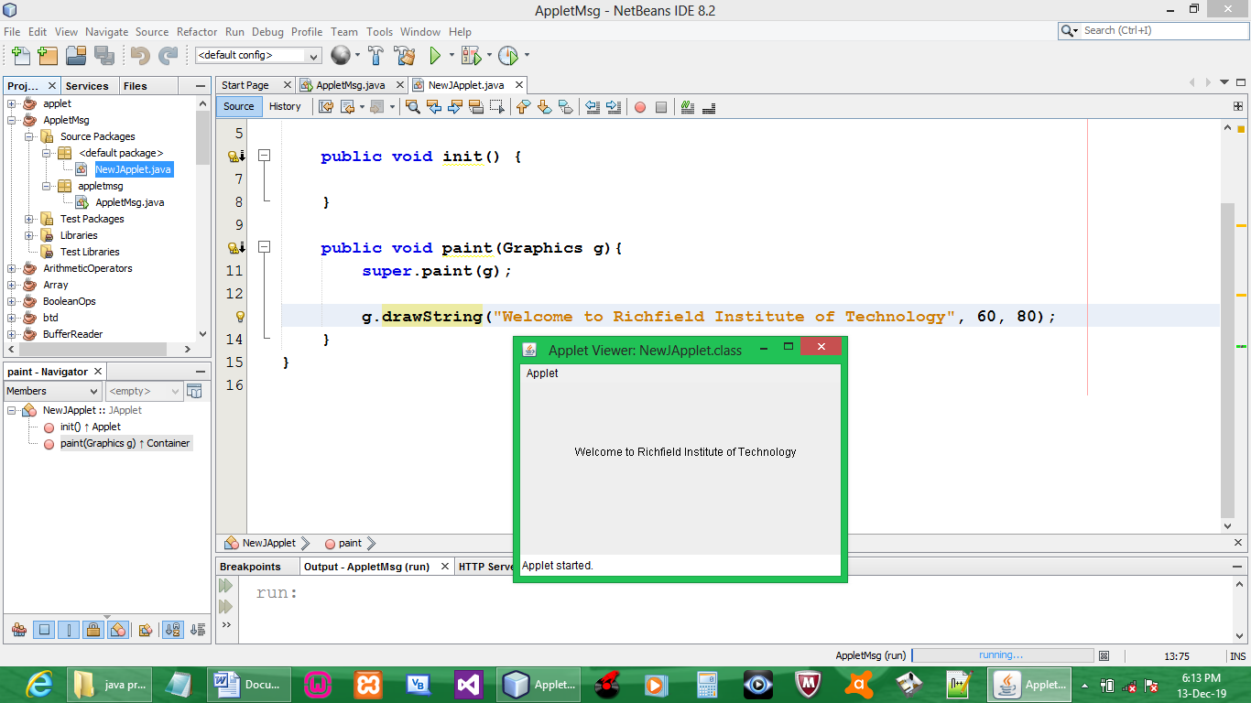

NB: missing color on applet and text

